**ECE-3502 IoT Domain Analyst LAB(L9+L10)**

**Name: Alpanshu Kataria**

**Reg. No.: 18BCE1267**

**Faculty: Maheshwari R**

Lab 2

**Task:**

Using node red build a web based application to automate smart parking system in metro station. Create a sreative and stylish form(Through HTML and CSS) to get car owner details to automate the parking system. Display the retrieved details in UI and debug monitor.

Create a hyperlink to know the parking rates of metro station.

**Flow:**

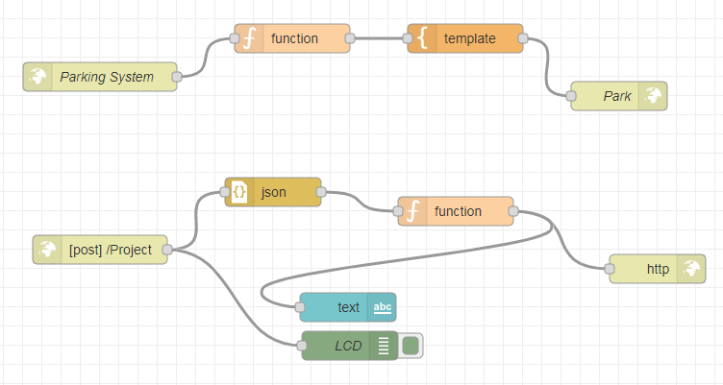

**Nodes:**

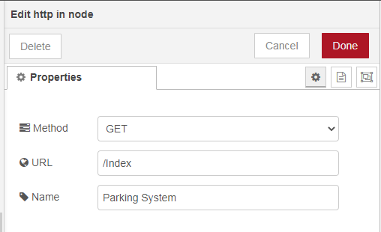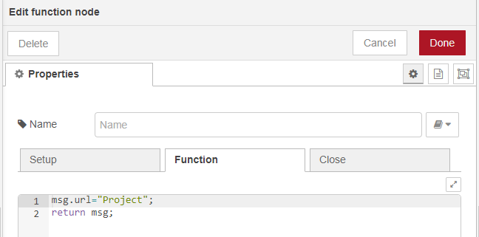

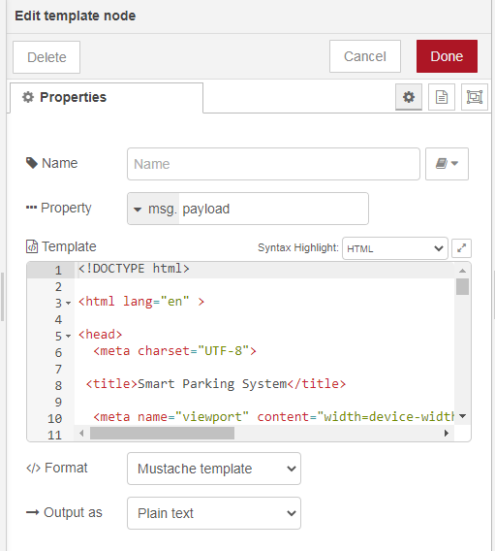

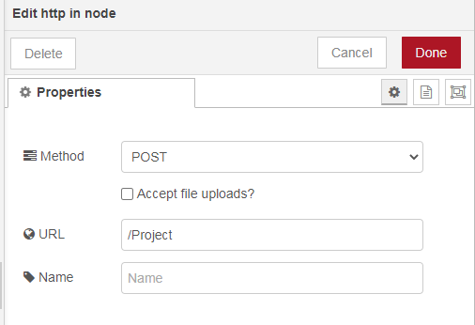

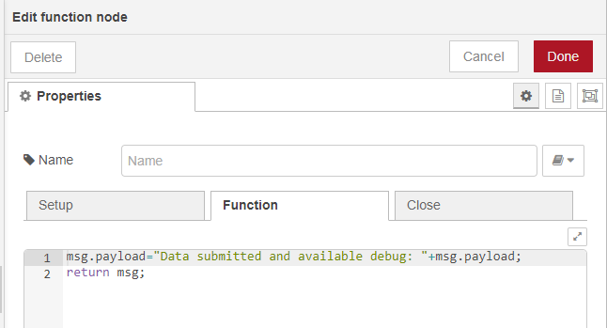

**HTML Code:**

|  |  |
| --- | --- |
|  | <!DOCTYPE html> |
|  |  |
|  | <html lang="en" > |
|  |  |
|  | <head> |
|  | <meta charset="UTF-8"> |
|  |  |
|  | <title>Smart Parking System</title> |
|  |  |
|  | <meta name="viewport" content="width=device-width, initial-scale=1.0"> |
|  | <link rel="stylesheet" href="<https://cdnjs.cloudflare.com/ajax/libs/normalize/5.0.0/normalize.min.css>"> |
|  |  |
|  | <style> |
|  |  |
|  | @import url(https://fonts.googleapis.com/css?family=Lato:300,400,700); |
|  | body { |
|  | background-color: #e6e6e6; |
|  | font-size: 100%; |
|  | font-family: 'Lato', sans-serif; |
|  | font-weight: 400; |
|  | } |
|  |  |
|  | div, textarea, input { |
|  | -moz-box-sizing: border-box; |
|  | -webkit-box-sizing: border-box; |
|  | box-sizing: border-box; |
|  | } |
|  |  |
|  | .container { |
|  | max-width: 510px; |
|  | min-width: 324px; |
|  | margin: 50px auto 0px; |
|  | background-color: #fff; |
|  | border: 1px solid #cfcfcf; |
|  | border-bottom: 3px solid #ccc; |
|  | } |
|  |  |
|  | .row { |
|  | width: 100%; |
|  | margin: 0 0 1em 0; |
|  | padding: 0 2.5em; |
|  | } |
|  | .row.header { |
|  | padding: 1.5em 2.5em; |
|  | border-bottom: 1px solid #ccc; |
|  | background: url(https://image.shutterstock.com/image-vector/parking-zone-car-area-space-600w-1176392119.jpg) left -80px; |
|  | color: #fff; |
|  | } |
|  | .row.body { |
|  | padding: .5em 2.5em 1em; |
|  | } |
|  |  |
|  | .pull-right { |
|  | float: right; |
|  | } |
|  |  |
|  | h1 { |
|  | font-family: 'Lato', sans-serif; |
|  | font-weight: 300; |
|  | display: inline-block; |
|  | font-weight: 100; |
|  | background-color: white; |
|  | color: black; |
|  | text-shadow: 2px 2px 5px red; |
|  | font-size: 3.5em; |
|  | border-bottom: 1px solid rgba(255, 255, 255, 0.3); |
|  | margin: 0 0 0.1em 0; |
|  | padding: 0 0 0.4em 0; |
|  | } |
|  |  |
|  | h3 { |
|  | font-family: 'Lato', sans-serif; |
|  | font-weight: 400; |
|  | font-size: 1.25em; |
|  | color: black; |
|  | text-shadow: 2px 2px 5px red; |
|  | margin: 1em 0 0.4em 0; |
|  | } |
|  |  |
|  | .btn { |
|  | font-size: 1.0625em; |
|  | display: inline-block; |
|  | padding: 0.74em 1.5em; |
|  | margin: 1.5em 0 0; |
|  | color: #fff; |
|  | border-width: 0 0 0 0; |
|  | border-bottom: 5px solid; |
|  | text-transform: uppercase; |
|  | background-color: #b3b3b3; |
|  | border-bottom-color: #8c8c8c; |
|  | font-family: 'Lato', sans-serif; |
|  | font-weight: 300; |
|  | } |
|  | .btn:hover { |
|  | background-color: #bfbfbf; |
|  | } |
|  | .btn.btn-submit { |
|  | background-color: #4f6fad; |
|  | border-bottom-color: #374d78; |
|  | } |
|  | .btn.btn-submit:hover { |
|  | background-color: #5f7db6; |
|  | } |
|  |  |
|  | form { |
|  | max-width: 100%; |
|  | display: block; |
|  | } |
|  | form ul { |
|  | margin: 0; |
|  | padding: 0; |
|  | list-style: none; |
|  | } |
|  | form ul li { |
|  | margin: 0 0 0.25em 0; |
|  | clear: both; |
|  | display: inline-block; |
|  | width: 100%; |
|  | } |
|  | form ul li:last-child { |
|  | margin: 0; |
|  | } |
|  | form ul li p { |
|  | margin: 0; |
|  | padding: 0; |
|  | float: left; |
|  | } |
|  | form ul li p.right { |
|  | float: right; |
|  | } |
|  | form ul li .divider { |
|  | margin: 0.5em 0 0.5em 0; |
|  | border: 0; |
|  | height: 1px; |
|  | width: 100%; |
|  | display: block; |
|  | background-color: #4f6fad; |
|  | background-image: linear-gradient(to right, #ee9cb4, #4f6fad); |
|  | } |
|  | form ul li .req { |
|  | color: #ee9cb4; |
|  | } |
|  | form label { |
|  | display: block; |
|  | margin: 0 0 0.5em 0; |
|  | color: #4f6fad; |
|  | font-size: 1em; |
|  | } |
|  | form input { |
|  | margin: 0 0 0.5em 0; |
|  | border: 1px solid #ccc; |
|  | padding: 6px 10px; |
|  | color: #555; |
|  | font-size: 1em; |
|  | } |
|  | form textarea { |
|  | border: 1px solid #ccc; |
|  | padding: 6px 10px; |
|  | width: 100%; |
|  | color: #555; |
|  | } |
|  | form small { |
|  | color: #4f6fad; |
|  | margin: 0 0 0 0.5em; |
|  | } |
|  |  |
|  | @media only screen and (max-width: 480px) { |
|  | .pull-right { |
|  | float: none; |
|  | } |
|  |  |
|  | input { |
|  | width: 100%; |
|  | } |
|  |  |
|  | label { |
|  | width: 100%; |
|  | display: inline-block; |
|  | float: left; |
|  | clear: both; |
|  | } |
|  |  |
|  | li, p { |
|  | width: 100%; |
|  | } |
|  |  |
|  | input.btn { |
|  | margin: 1.5em 0 0.5em; |
|  | } |
|  |  |
|  | h1 { |
|  | font-size: 2.25em; |
|  | } |
|  |  |
|  | h3 { |
|  | font-size: 1.125em; |
|  | } |
|  |  |
|  | li small { |
|  | display: none; |
|  | } |
|  | } |
|  |  |
|  |  |
|  | </style> |
|  |  |
|  | </head> |
|  |  |
|  | <body> |
|  | <!-- partial:index.partial.html --> |
|  |  |
|  |  |
|  |  |
|  | <div class="container"> |
|  | <div class="row header"> |
|  | <h1>Smart Parking System &nbsp;</h1> |
|  | <h3>Fill out the form below to book a slot!</h3> |
|  | </div> |
|  | <div class="row body"> |
|  |  |
|  | <p><a href = "[Parking rates at metro station.docx](http://127.0.0.1:1880/Parking%20rates%20at%20metro%20station.docx)" > See the rate list here</a></p> |
|  |  |
|  | <form method="post" action="/Project"> |
|  | <ul> |
|  |  |
|  | <li> |
|  | <p class="left"> |
|  | <label for="first_name">first name</label> |
|  | <input type="text" name="first_name" placeholder="Alpanshu" /> |
|  | </p> |
|  | <p class="pull-right"> |
|  | <label for="last_name">last name</label> |
|  | <input type="text" name="last_name" placeholder="Kataria" /> |
|  | </p> |
|  | </li> |
|  |  |
|  | <li> |
|  | <p> |
|  | <label for="email">email <span class="req">*</span></label> |
|  | <input type="email" name="email" placeholder="alpanshu.kataria@gmail.com" /> |
|  | </p> |
|  | </li> |
|  | <li> |
|  | <p> |
|  | <label for="Mob. No.">Mob. No.<span class="req">*</span></label> |
|  | <input type="Mob. No." name="Mob. No." placeholder="Mob. No." /> |
|  | </p> |
|  | </li> |
|  | <li> |
|  | <p> |
|  | <label for="Car. No.">Car. No.<span class="req">*</span></label> |
|  | <input type="Car. No." name="Car. No." placeholder="Car. No." /> |
|  | </p> |
|  | </li> |
|  | <li><div class="divider"></div></li> |
|  | <li> |
|  | <label for="Address">Address</label> |
|  | <textarea cols="46" rows="3" name="Address"></textarea> |
|  | </li> |
|  |  |
|  | <li> |
|  | <input class="btn btn-submit" type="submit" value="Submit" /> |
|  | <small>or press <strong>enter</strong></small> |
|  | </li> |
|  |  |
|  | </ul> |
|  | </form> |
|  | </div> |
|  | </div> |
|  |  |
|  |  |
|  |  |
|  | <!-- partial --> |
|  |  |
|  |  |
|  | </body> |
|  |  |
|  | </html> |
|  |  |

**Debug monitor:**

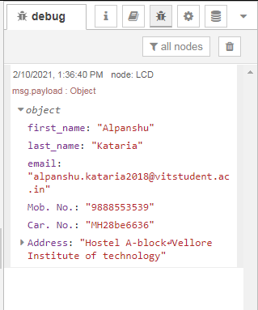

**Web Page:**

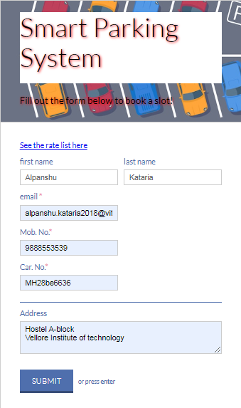

**Hyperlink to open Rate list**

**Rate list document:**

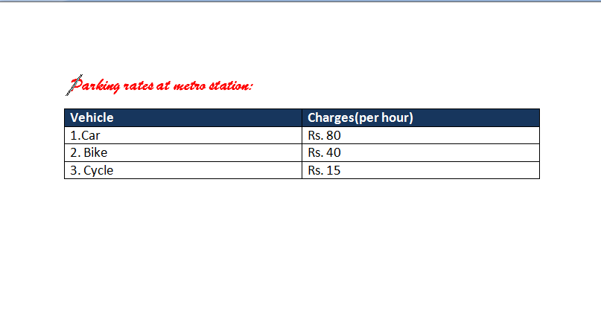

**Dashboard:**

